**EU DECLARATION OF CONFORMITY**

Distributed by: JBM CAMPLLONG, S.L.U.

Address: CIM La Selva – Crta. Aeroport Km 1.6 Nave 2.2, 17185 Vilobí d’Onyar, Girona

CIF: ESB17419292

Product’s description: 16 PIECES KIT WITH AIR WRENCH AND RATCHET

Manufacturer’s reference: WFR-1070

Distributor’s reference: 52156

The declaration object complies with the Directives 2006/42/EC (Machinery Directive); and the following standards:

|  |  |  |
| --- | --- | --- |
| **Standard** | **Title** | **Edition/Date** |
| EN ISO 11148-6 | Hand-held non-electric power tools - Safety requirements - Part 6: Assembly power tools for threaded fasteners. | 2012 |

Signed by:

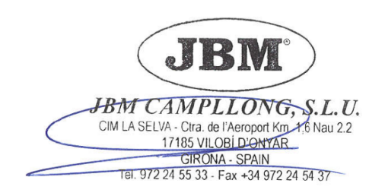

Eduard Godoy

Purchasing department director Girona, 16th August, 2021

